Use Subqueries, CTEs, and Window Functions to analyse sales data from the Superstore dataset.
Assignment-3
1.Load Superstore dataset into a table (superstore_raw).
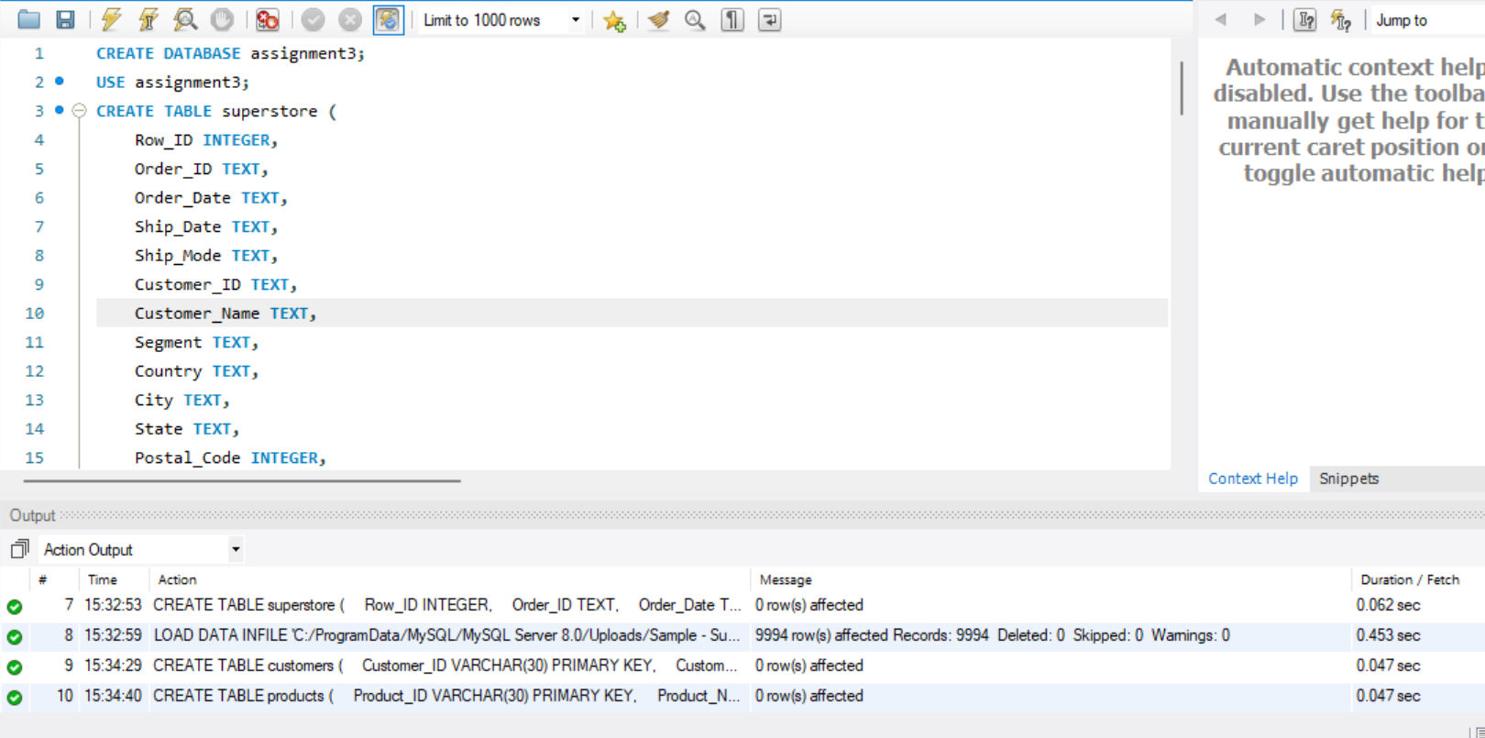

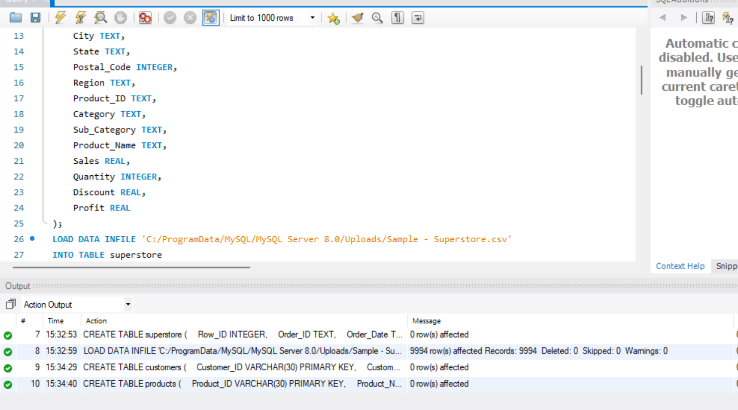

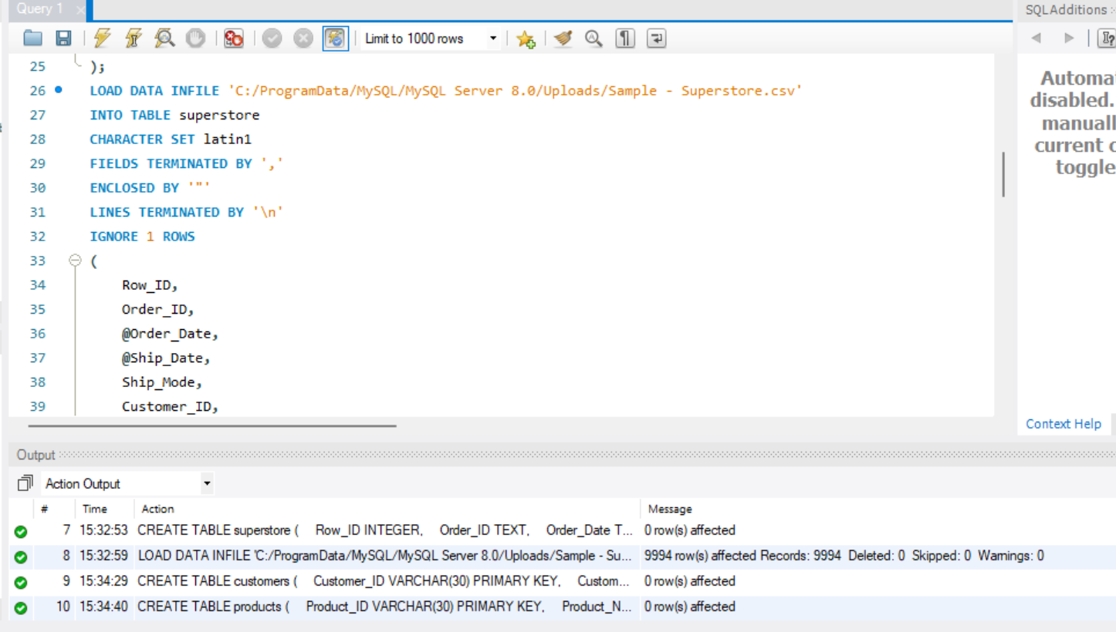

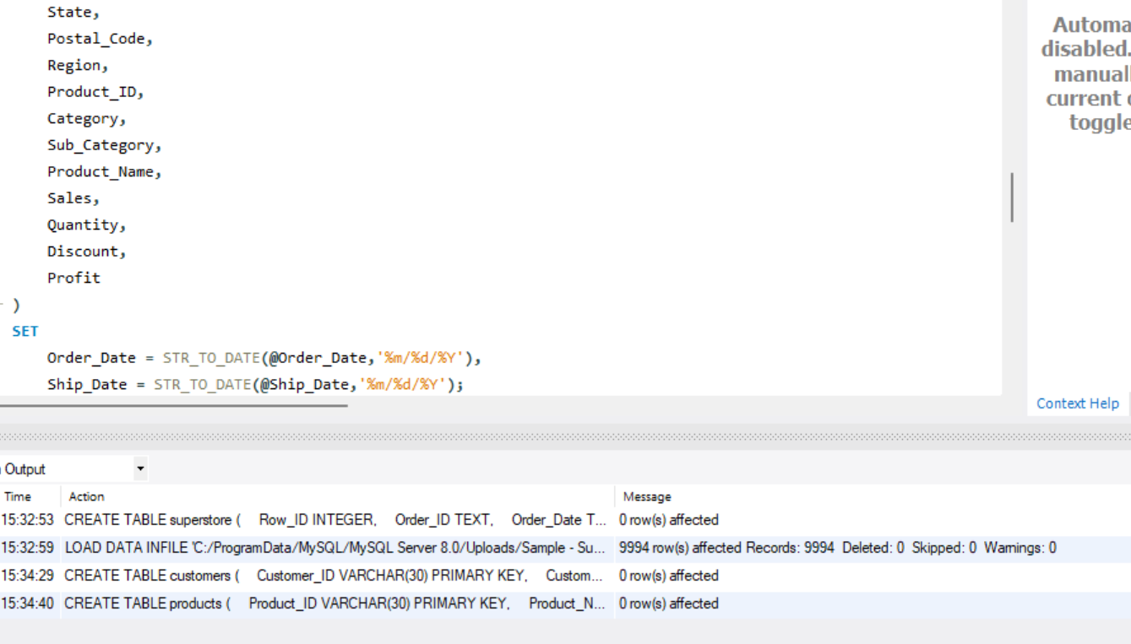

2. Create tables (customers, orders, products) from the dataset.

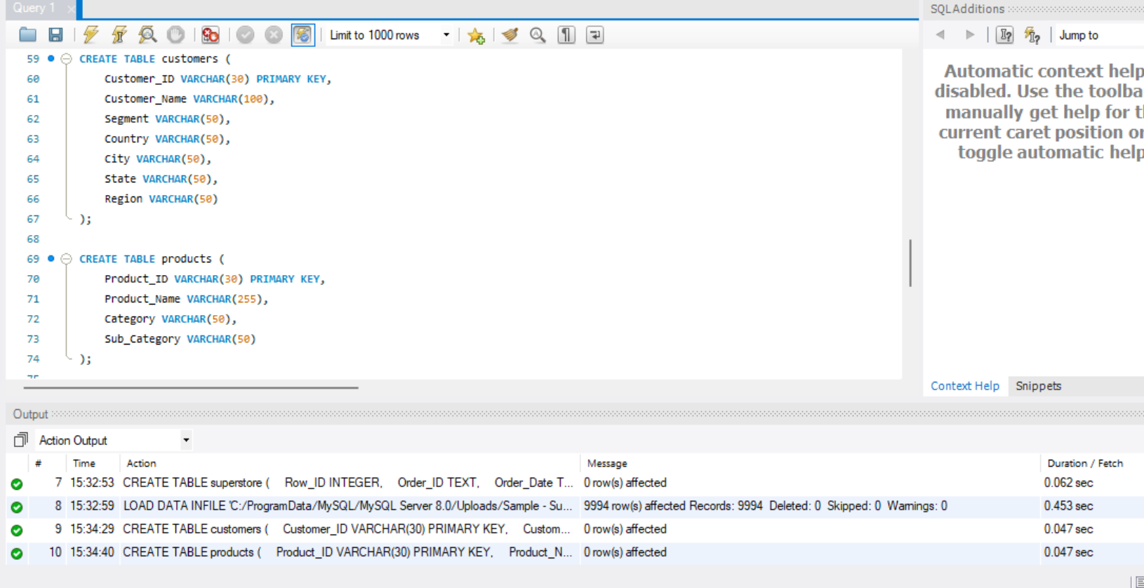

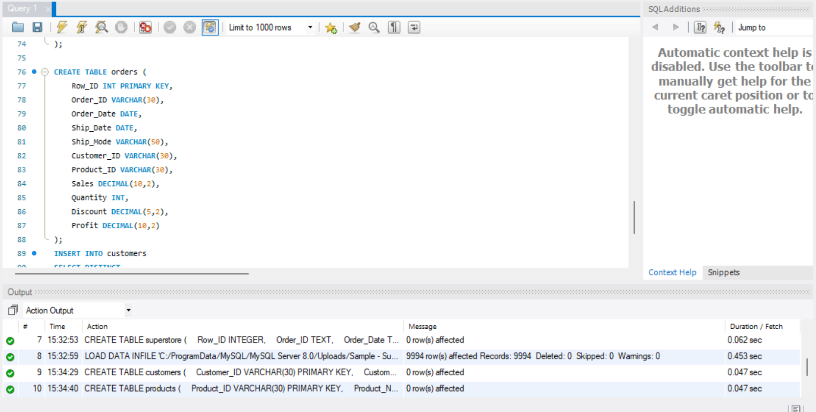

3.Insert data into these tables using SELECT DISTINCT.
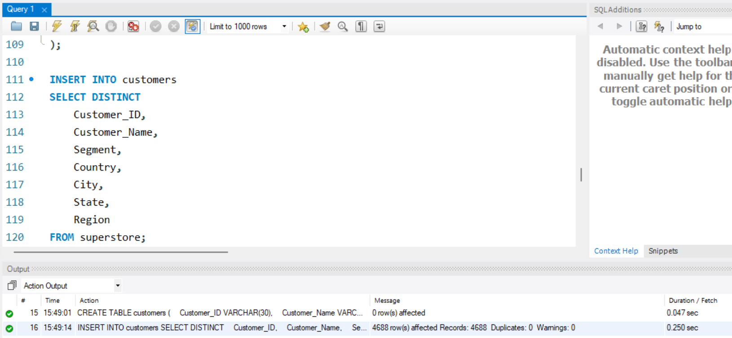

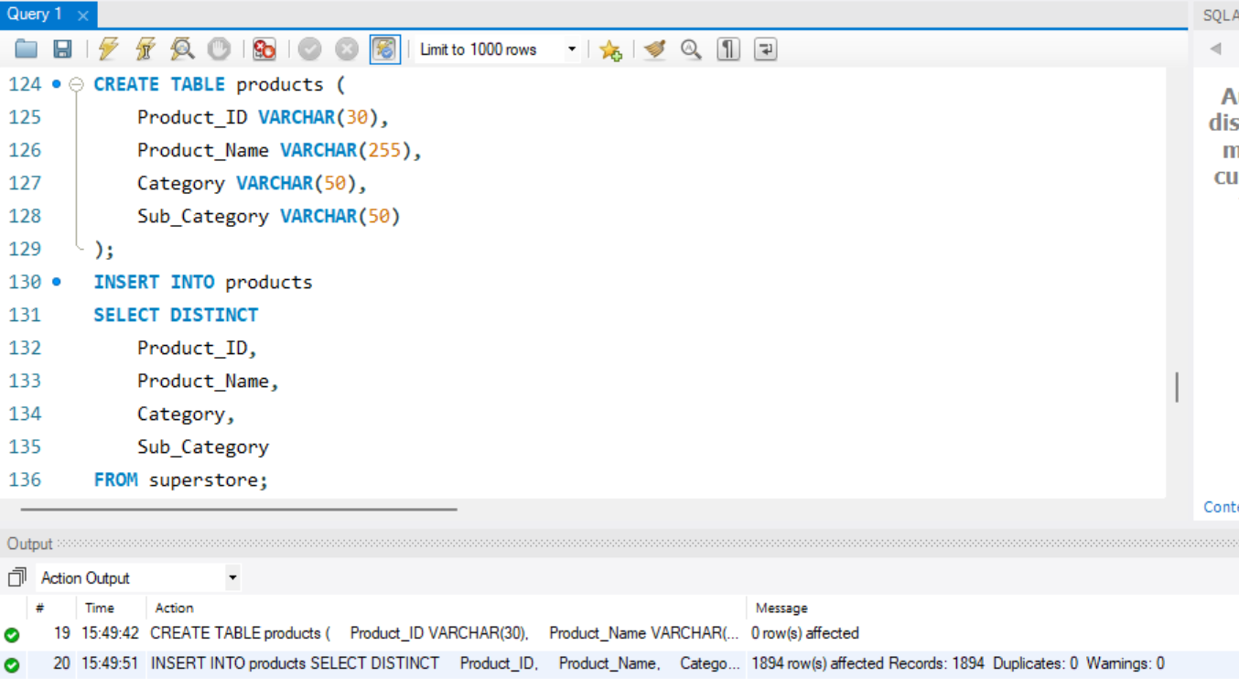
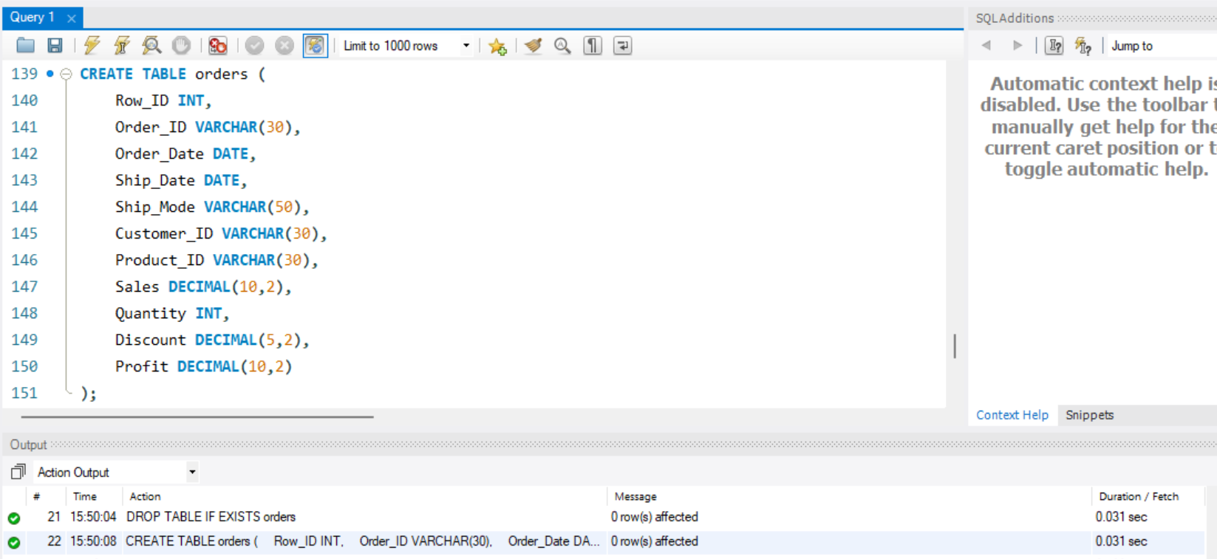

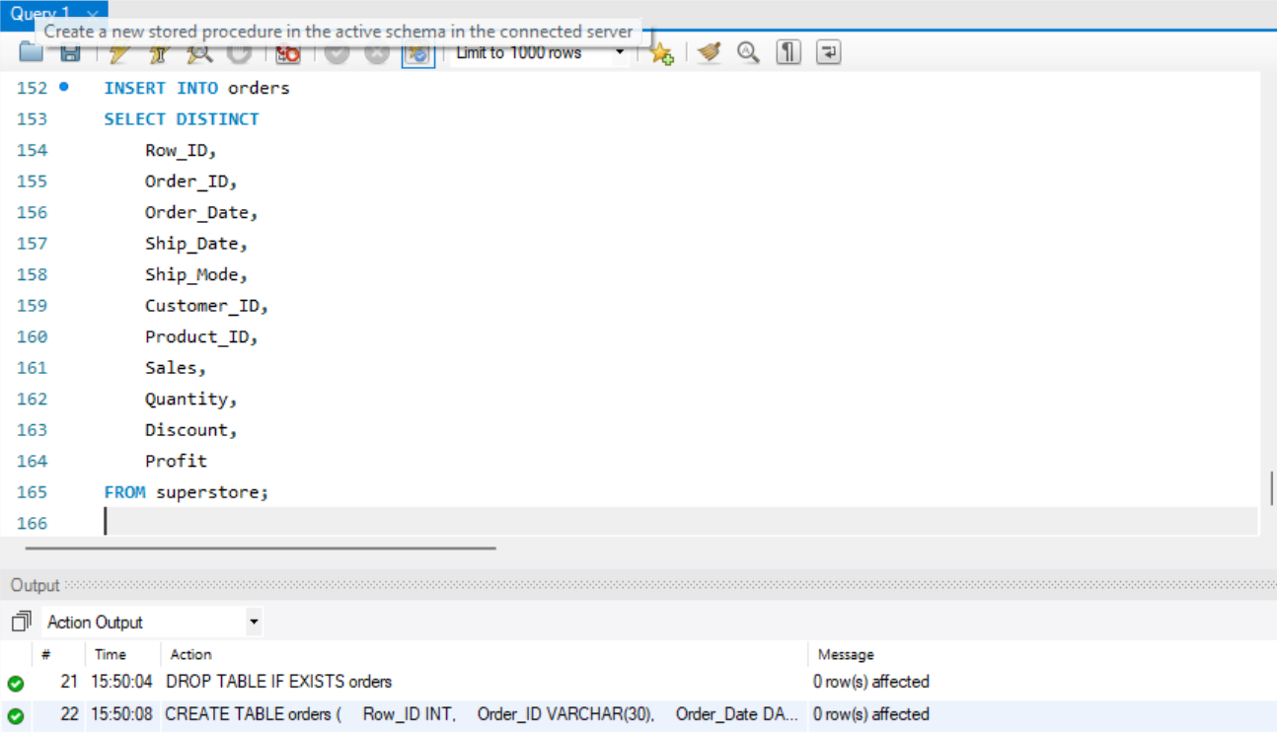

4. Apply subqueries to filter data (above average sales, highest order per customer).
i. Customers Spending More Than Their Region's Average
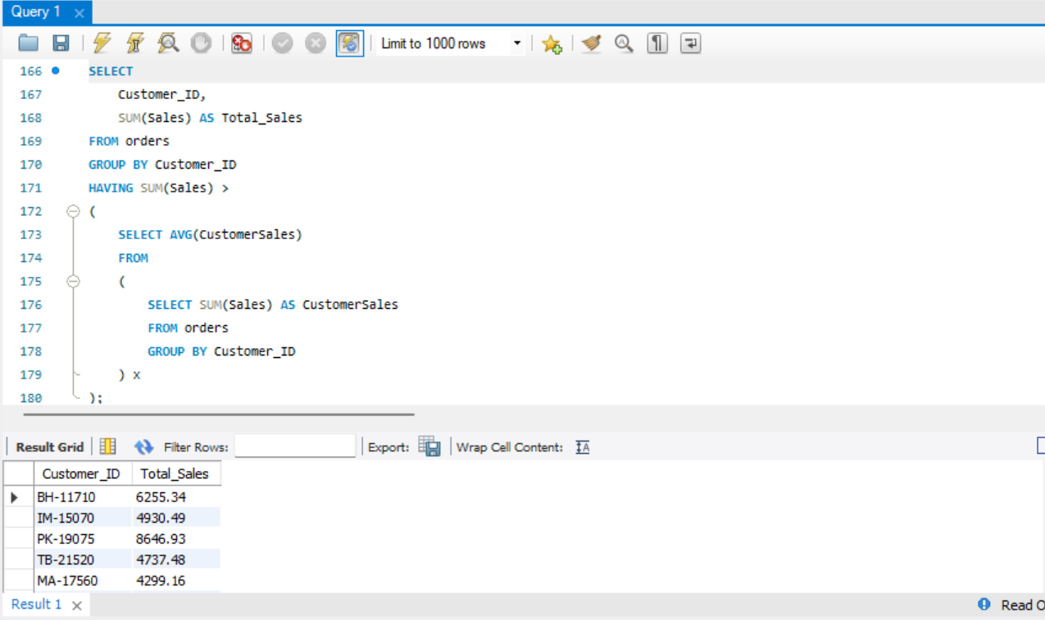
ii. Find customers whose highest order exceeds ₹1000:

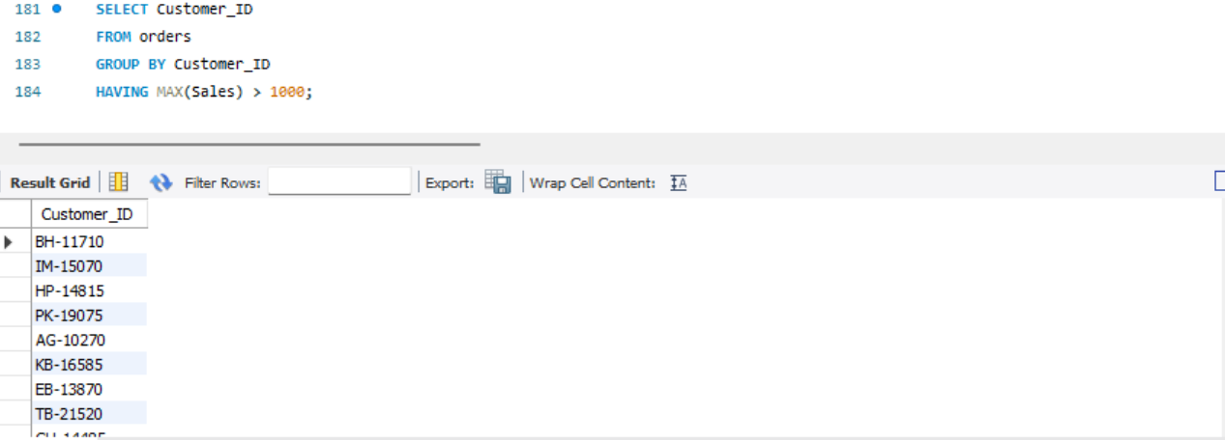

5.Use CTEs to compute aggregations (total sales per customer).

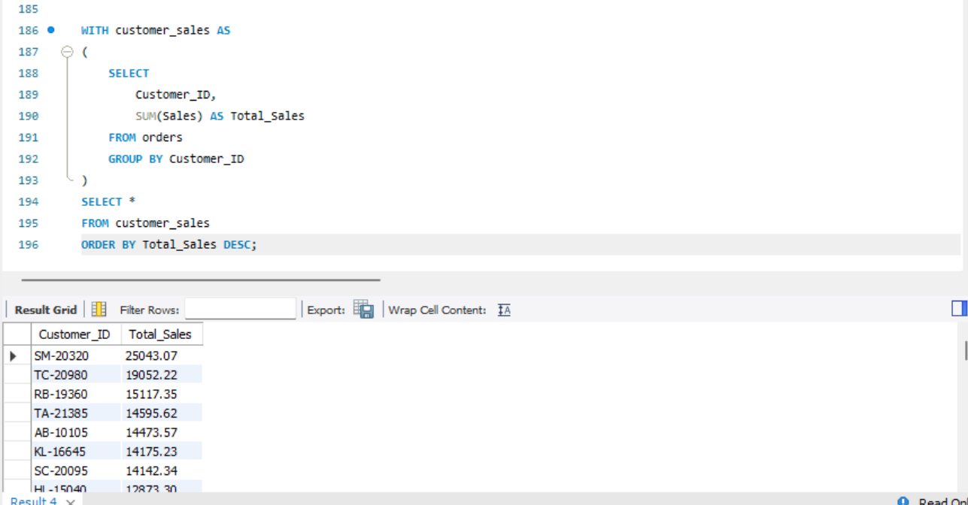

6. Apply window functions (ROW_NUMBER, RANK) for ranking and analysis.

- Rank Customers by Total Sales Using RANK()
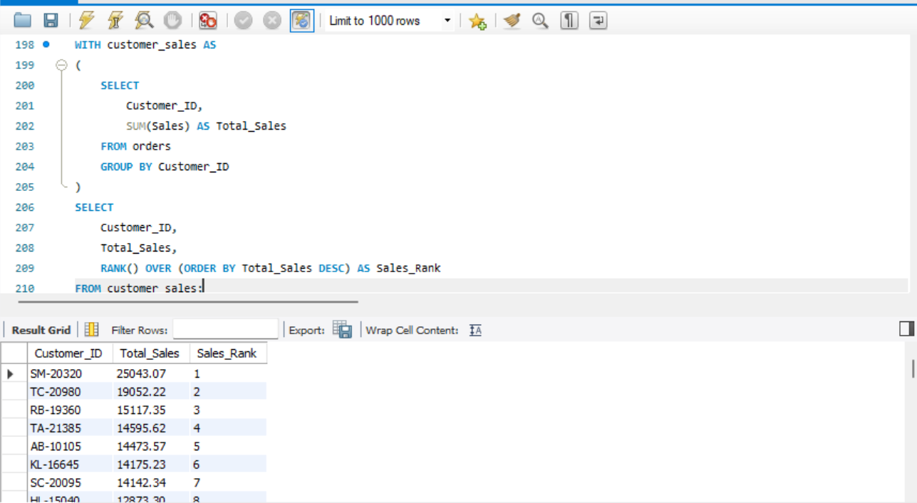

- Rank Products by Revenue
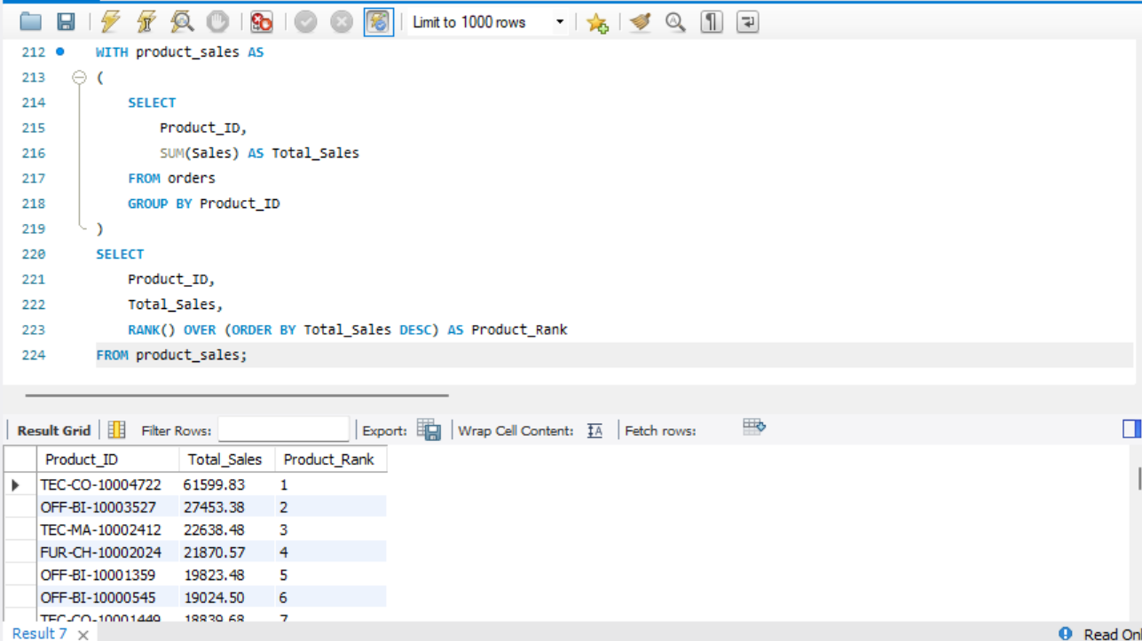

7.Combine JOIN + CTE + Window Functions for final result (customer, total sales, rank).
ROW_NUMBER() gives every customer a unique sequential position.
RANK() ranks customers by total sales and assigns the same rank to ties.
This helps identify top-performing customers and compare their revenue contributions.
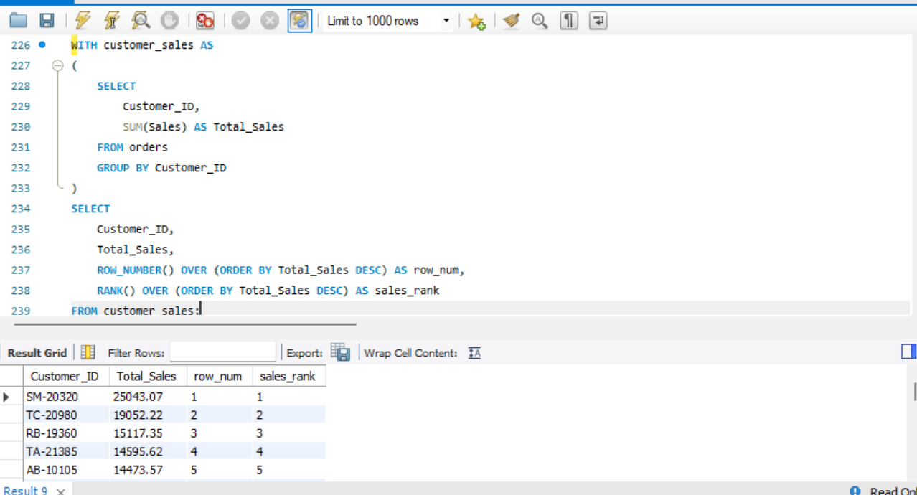
8. Solve business queries (top customers, low customers, single-order customers, above-average sales).
i. Top Customers by Sales
- Top customers contribute a significant portion of overall revenue.
- These customers are ideal candidates for loyalty and retention programs.
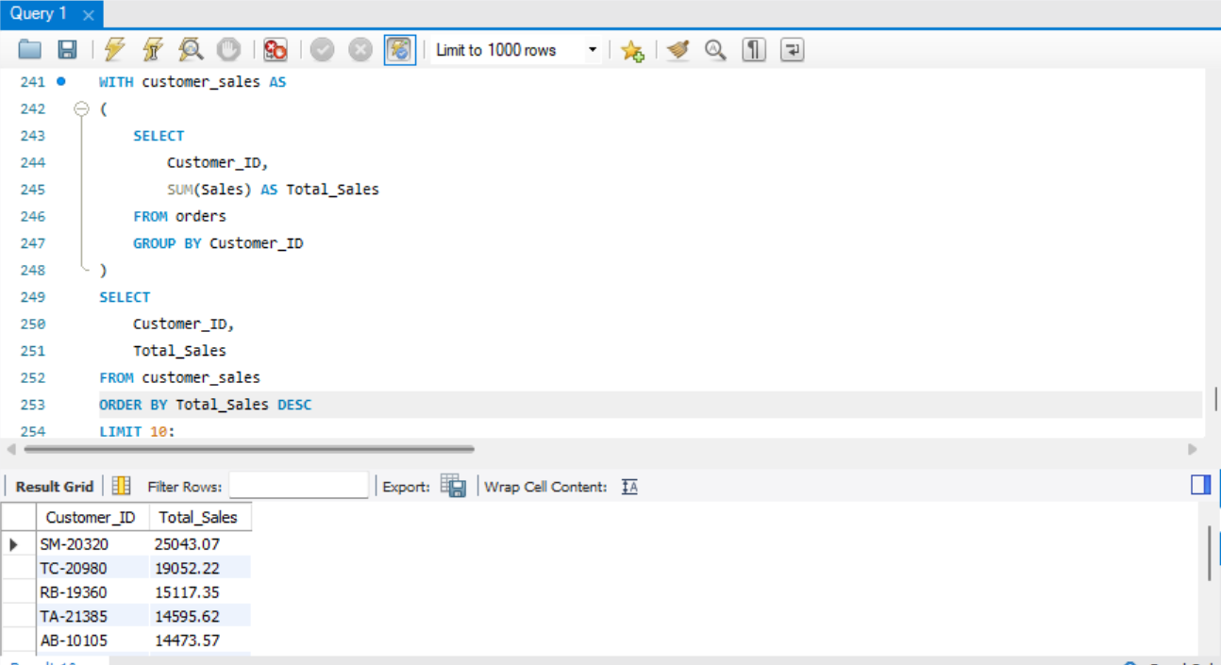
  - Low Customers (Lowest Sales)
• These customers generate very little revenue.
• Targeted marketing campaigns may increase engagement.
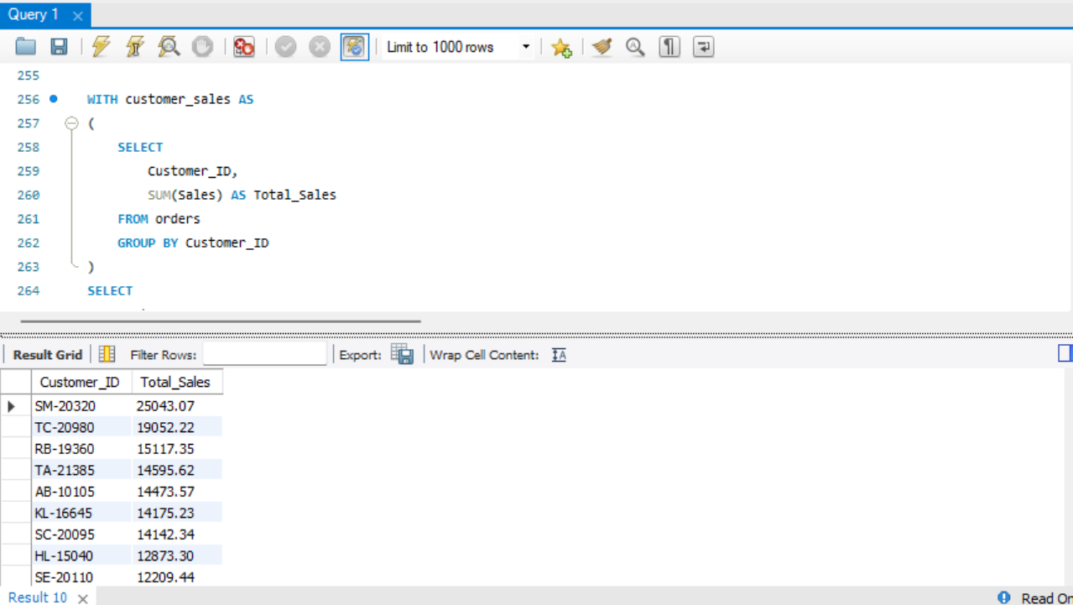
  - Single-Order Customers
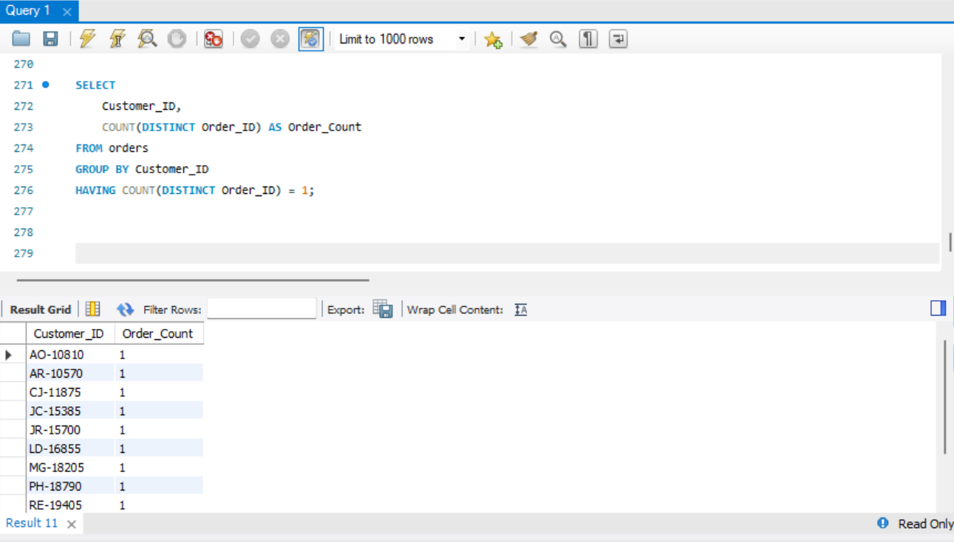
  - Above-Average Sales Customers
